Ryan Farruggia

CSC 35

Professor Ghansah

25 February 2021

Lab #3 Report

Image of source code before debugging:

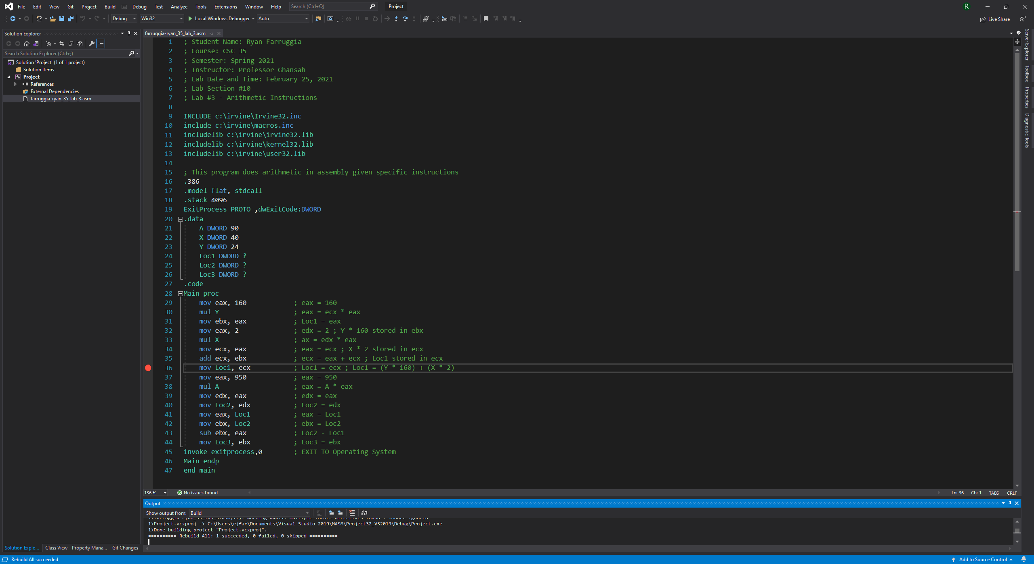

Image of source code before stepping over the breakpoint:

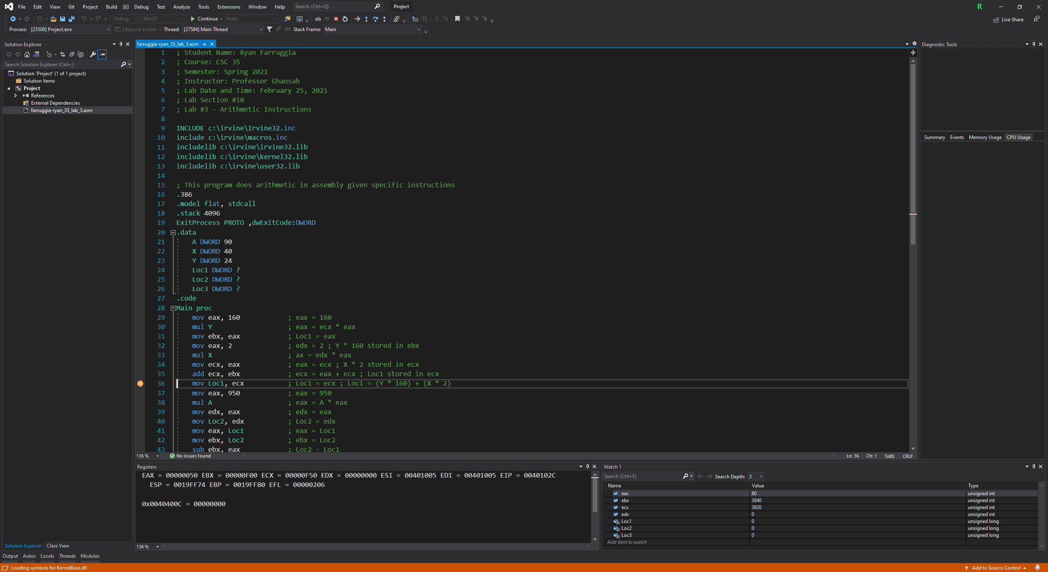

Debugging line 36 (mov Loc1, ecx):

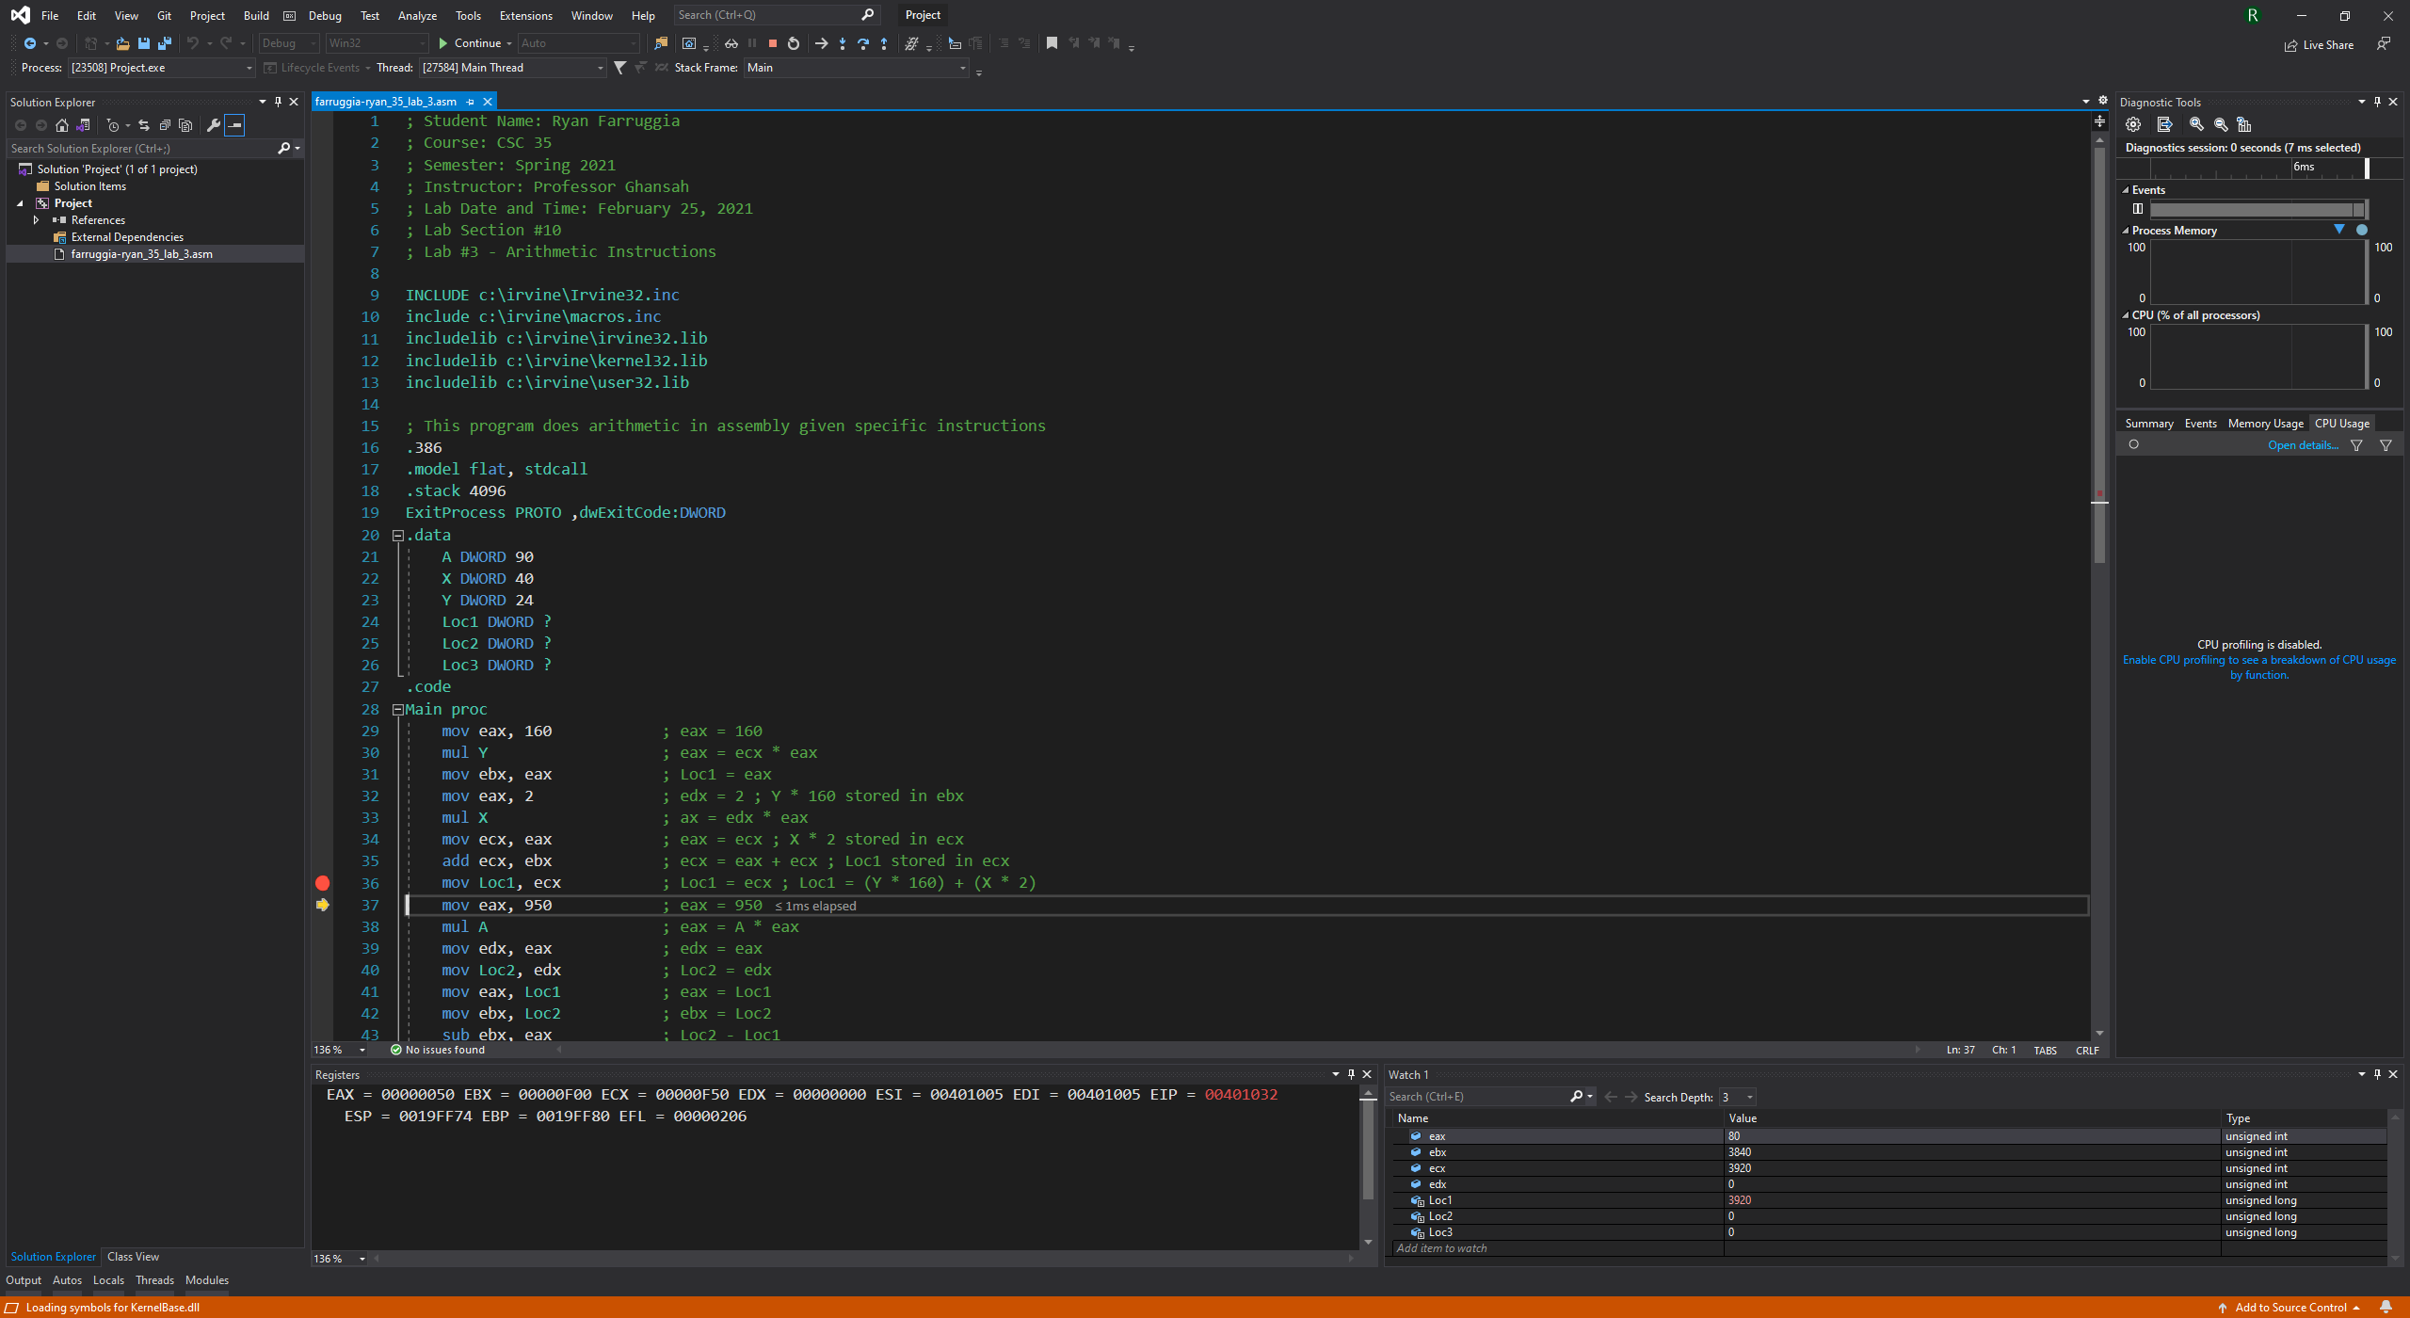

Debugging line 40 (mov Loc2, edx):

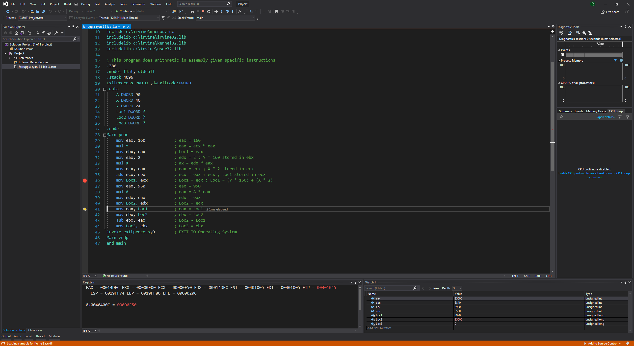

Debugging line 41 (mov eax, Loc1):

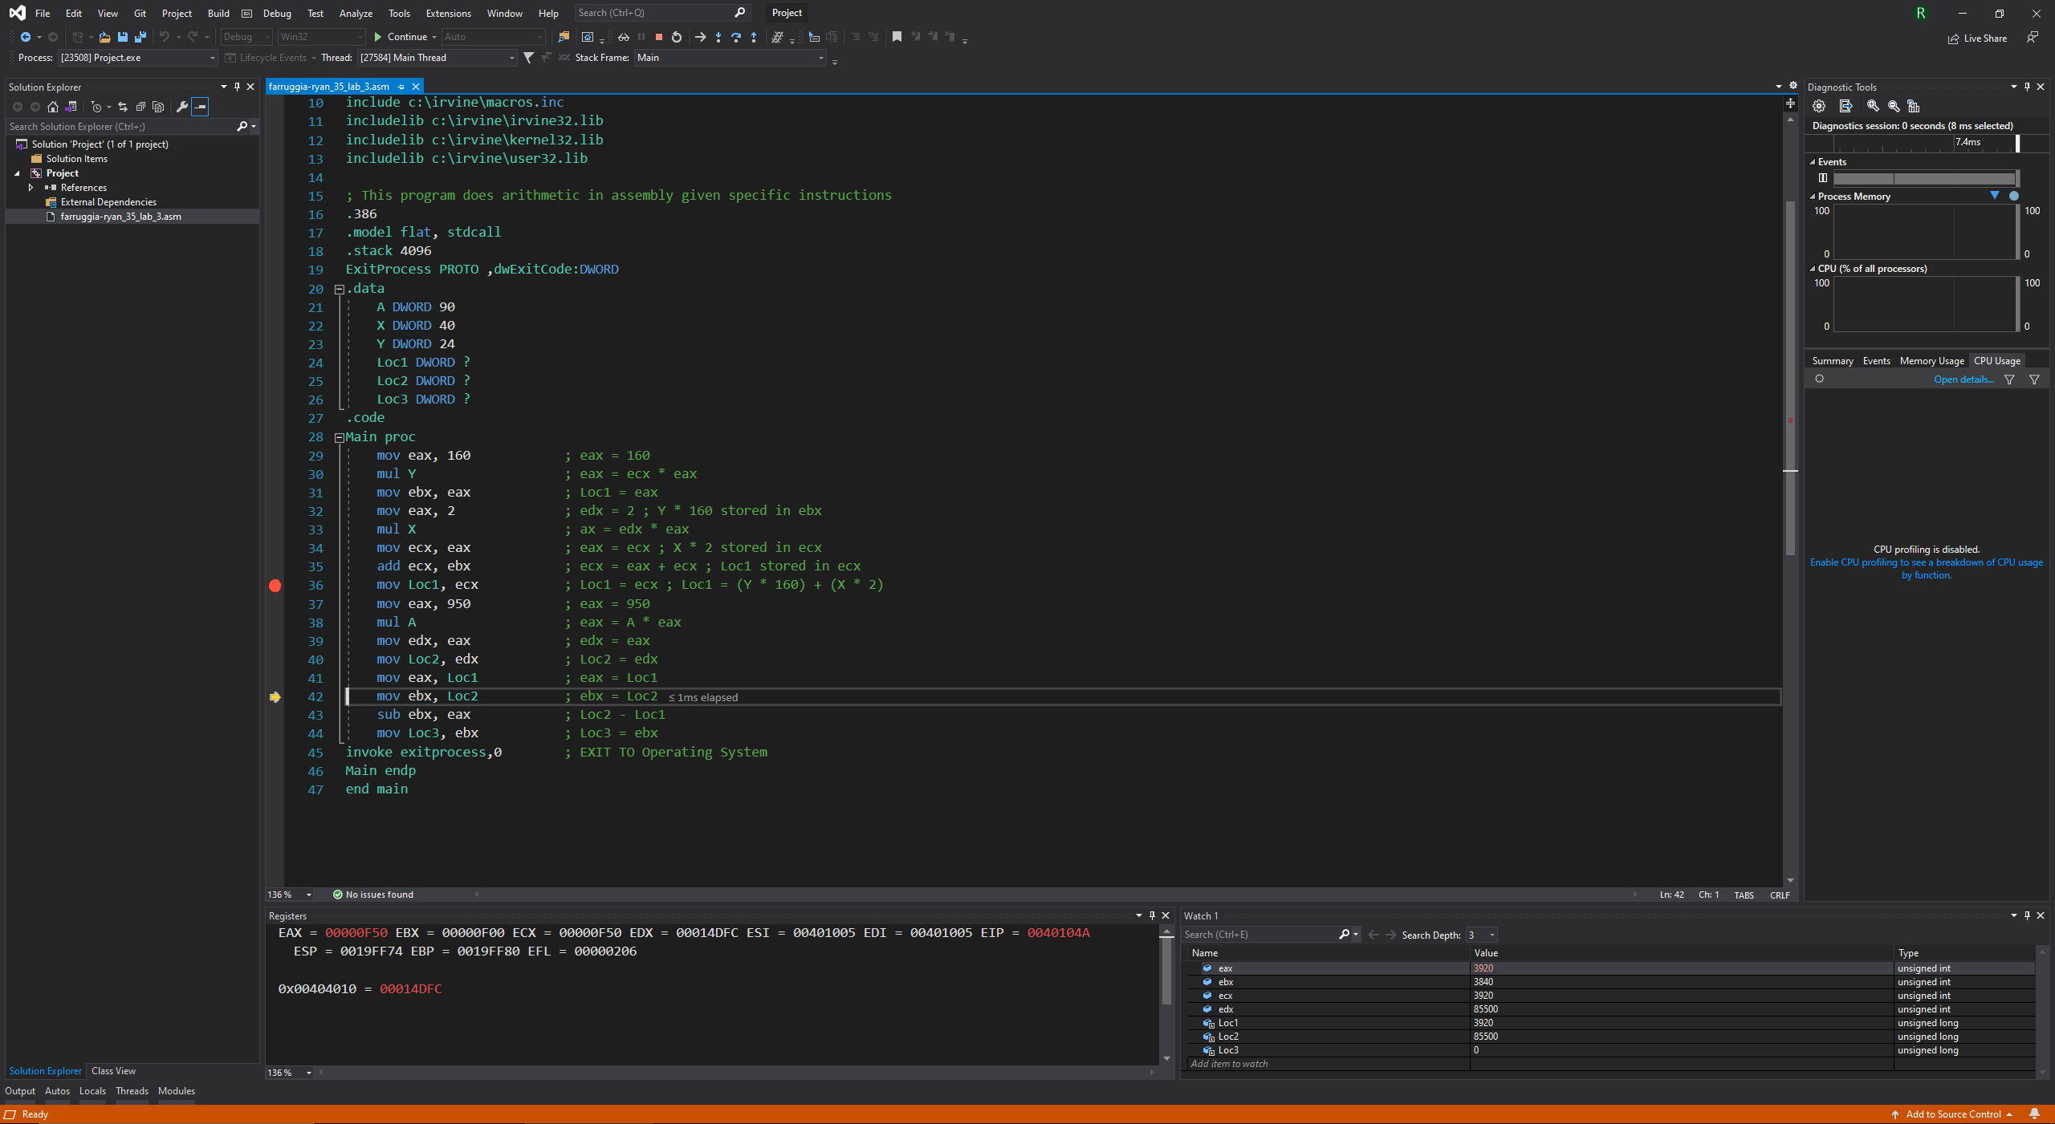

Debugging line 42 (mov ebx, Loc2):

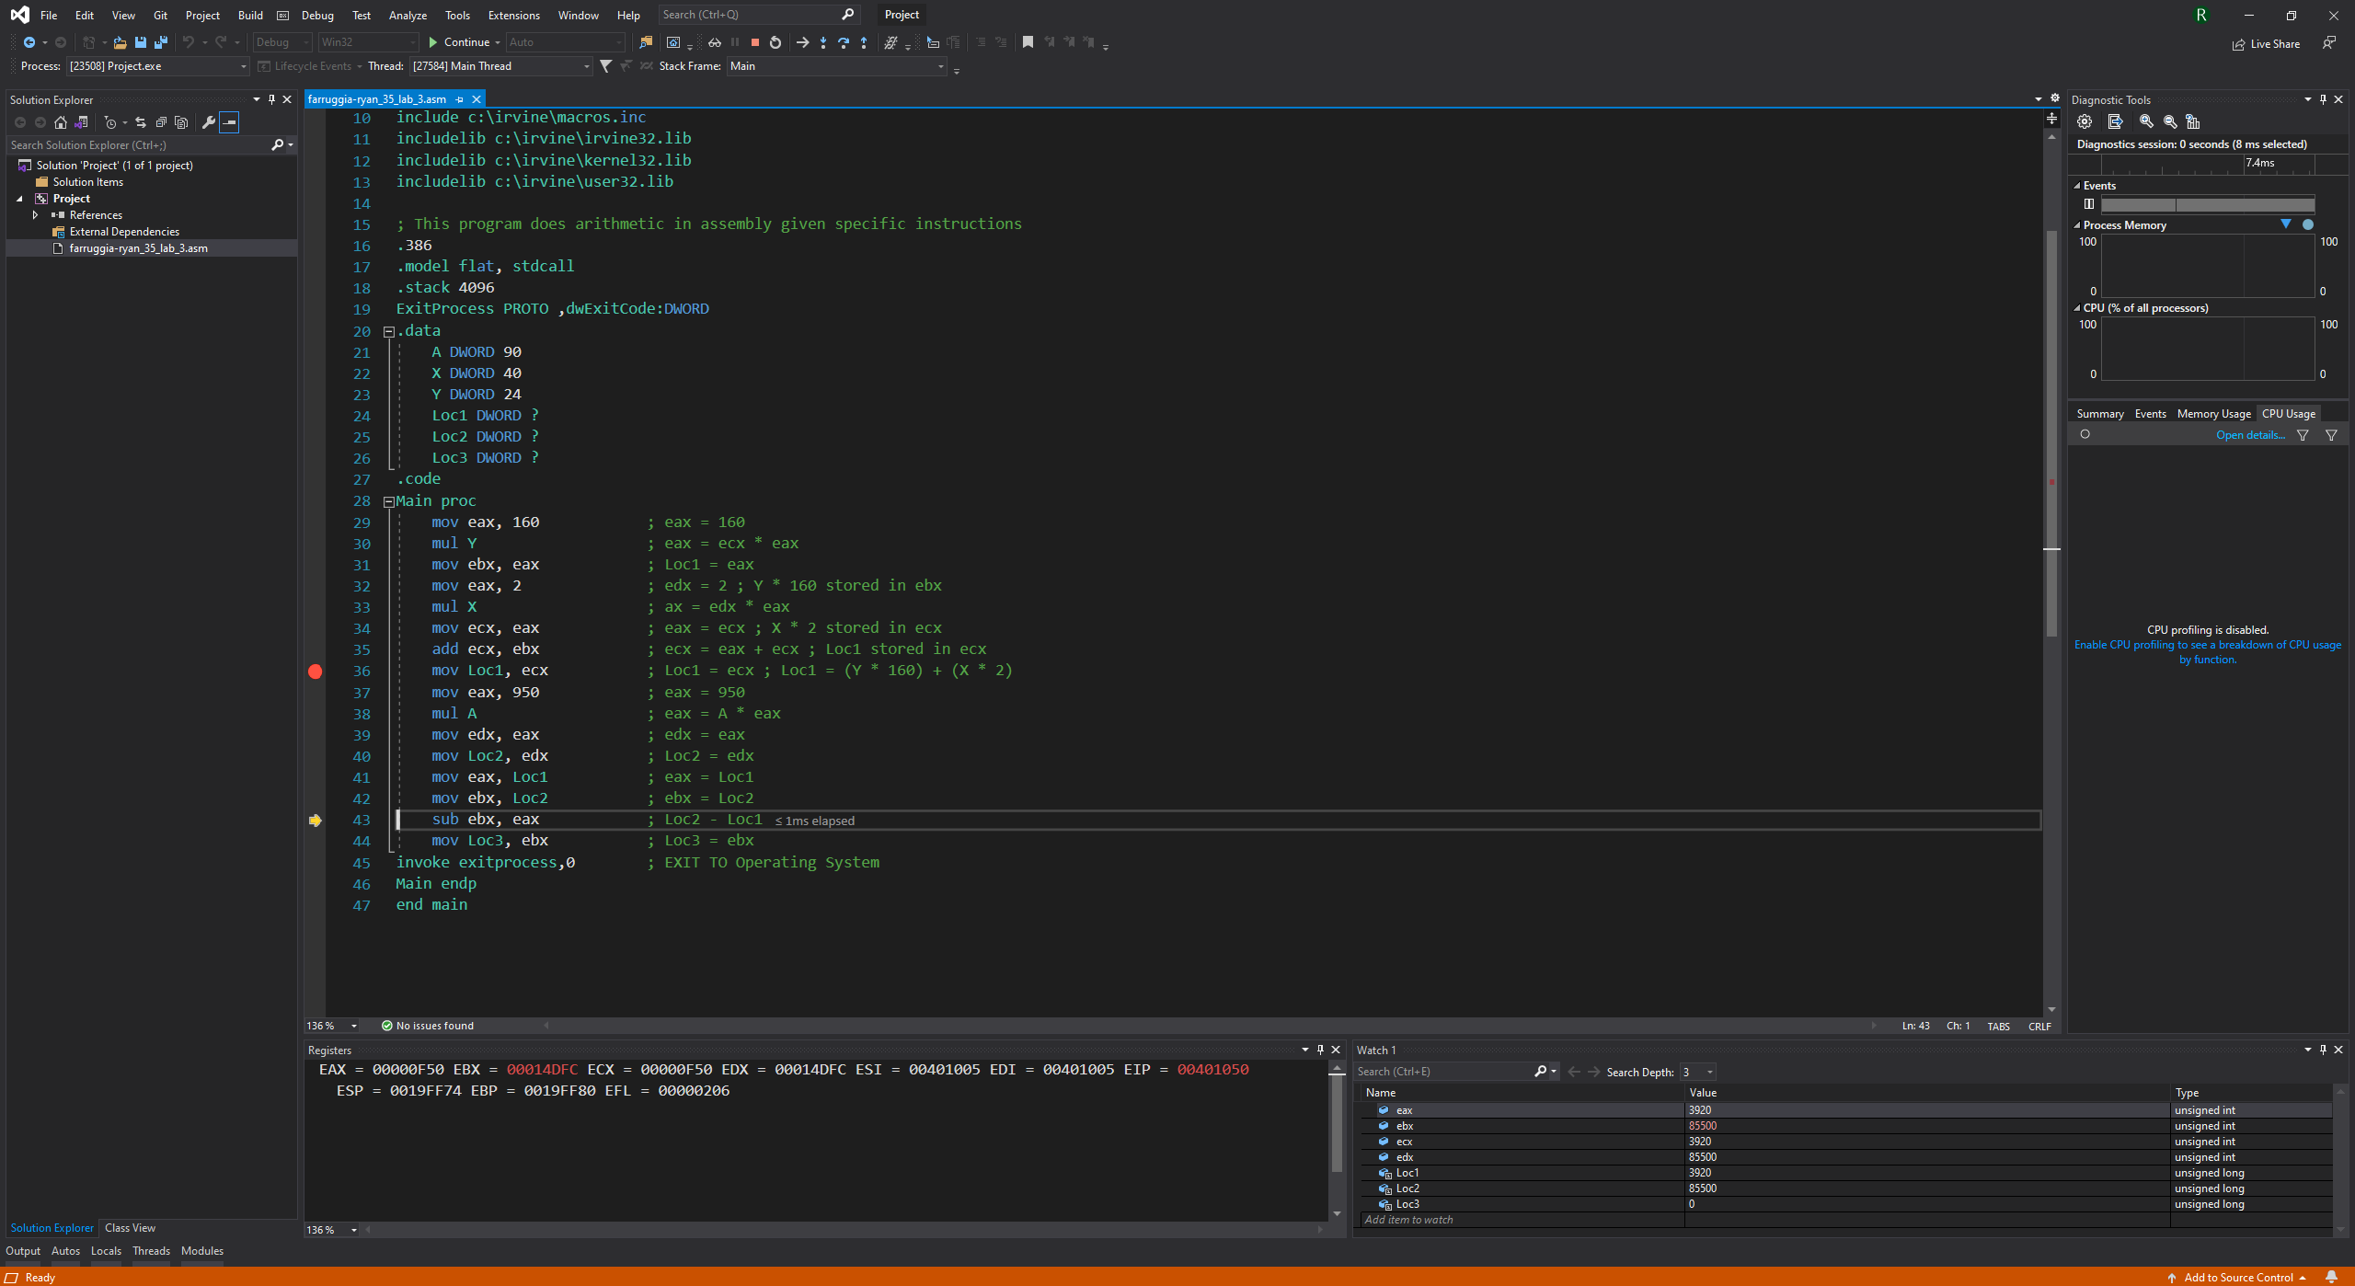

Debugging line 44 (mov Loc3, ebx):

